USER GUIDE
Time Series Analysis and Forecasting of COVID-19 using Machine Learning
Prerequisites
- Install Python 3.
- Google Colab/ Spyder/ Jupyter Notebook.
- Various types of Python Library, Packages and Modules need to install.
- Mount Google Drive with Google Colab.

In this work,We have used four different models to get the analysis and forecasting of COVID-19.
Overview
In this Work, We have collected Data from these resources Kaggle, WHO and DGHS.
For doing this experiment we have used Google Colab. Saving the dataset and training the model on cloud definitely helps to run project with large dataset. For this mount the Google Drive to Google Colab. Follow this procedure, Go to Google Colab then type as below

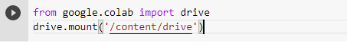

The cell will return a link. Go to the link to get the authorization code and paste the code and hit enter.

Drive become mounted at /content/drive. To run the experiment on Google Colab we need to import the dataset which we have collected from various sources.
To import the csv files on Google Colab from Local Machine use the following command.

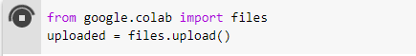

After run this cell, Choose the dataset named as covid_new.csv.
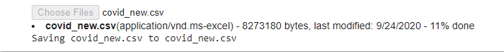
In a few minutes, the dataset will completely uploaded on Colab.
We got different typesof attributes from this data, attributes such as Date, S/No, Province/State, Country/Region, LastUpdate, Confirmed, Recovered and Deaths. We have checked the null values, drop the attributes which are not necessary for this dataset.

We convert the Date into a Date time frame for the time series analysis.
After executing this cellwe get the length and datatype as follows.

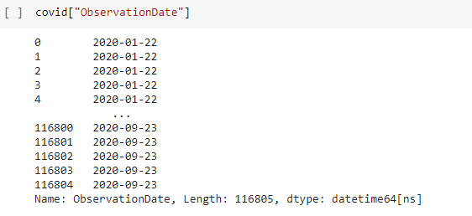
We have used groupby for confirmed, recovered and death cases datewise for combining the results. Itcan be used to group large amounts of data and compute operations on these groups.

We calculated the number of Active Cases and Closed Cases from the existing confirmed,recovered and death cases. We analyzed our datasets with different EDA methods and visualized those data to provide a sufficient consciousness regarding the outbreak of COVID‐19 all over the world and Bangladesh. Weekly Progress and Growth of different type of cases are showing in these figures as follows .
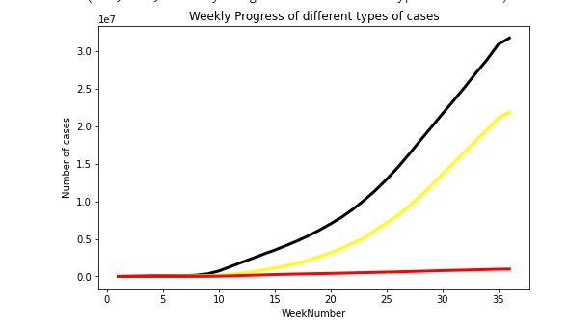
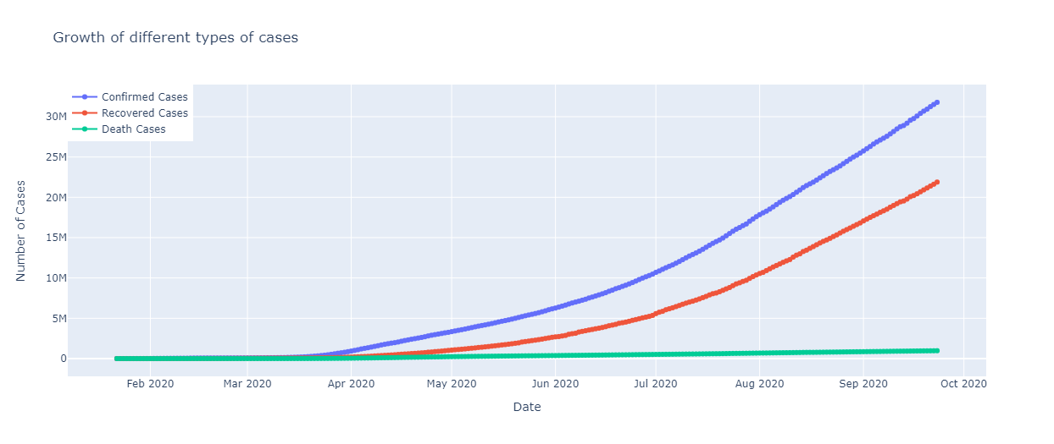

We have applied Linear Regression, Support Vector Regression, Holt’s Linear Trend Model and Holt-Winters’ multiplicative method on the world dataset and Bangladesh. We will check the error values compare between them. There are some basic steps we followed to implement these models.
- Import the packages and classes need for the model.
- Provide data to work with and eventually do appropriate transformations.
- Create a model which we want to implement and fit it with existing data.
- Check the results of model fitting to know whether the model is satisfactory.
- Apply the model for predictions.
In our experiment we have imported packages and classes as follows.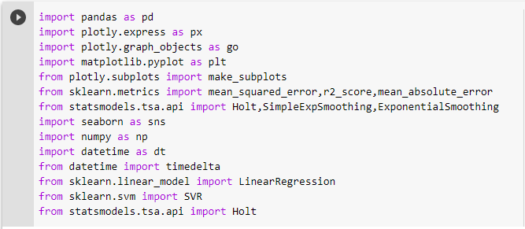
Train/Test is a method to measure the accuracy of model. It is called Train/Test because we split the the data set into two sets: a training set and a testing set. We test the model using the testing set. Train the model means create the model. Test the model means test the accuracy of the model.
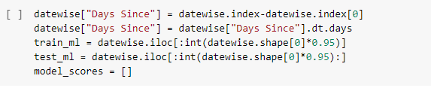
We have checked model fitted with our data or not. If model doesn’t fit with data correctly, the outcomes it produces will not be accurate enough to be useful for practical decision-making.Model fitting is a measure of how well a machine learning model generalizes to similar data to that on which it was trained. A model that is well-fitted produces more accurate outcomes. A model that is overfitted matches the data too closely. A model that is underfitted doesn’t match closely enough.
For Linear Regression and SVM we can use these codes on Google Colab.
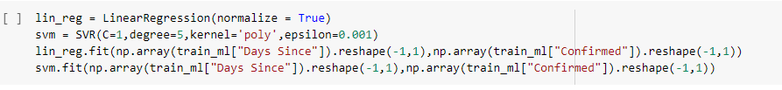
For Holt Linear Model, following code can be used to see model properly fitted or not.
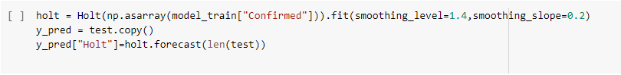
For Holt Winter Multiplicative Model, we use following code on Google Colab.
The predictive model's error rate can be evaluated by applying several accuracy metrics inmachine learning.MSE, MAE and RMSE used metrics to evaluate the prediction error rates and model performance.
- Mean absolute errorrepresents the difference between the original and predicted values extracted by averaged the absolute difference over the data set.
- Mean Squared Error represents the difference between the original and predicted values extracted by squared the average difference over the data set.
- Root Mean Squared Erroris the error rate by the square root of MSE
For Linear Regression,
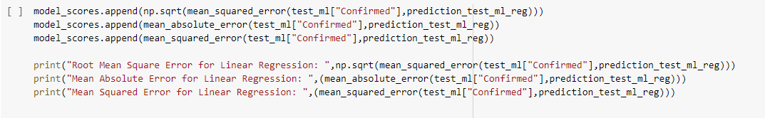
For SVM
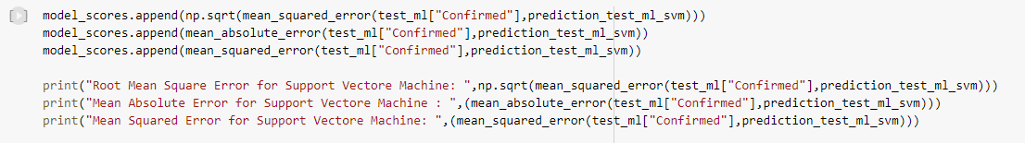
For Holt Linear Model
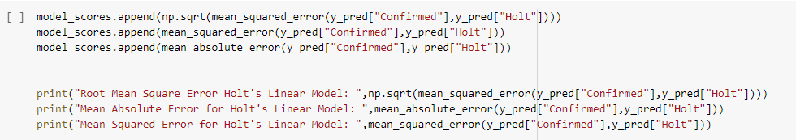
For Holt Winter Multiplicative Model
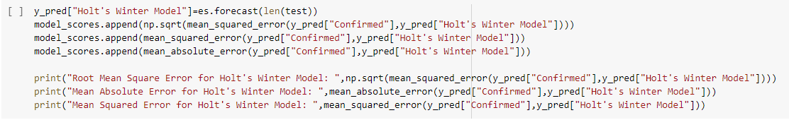
We have done prediction and time series analysis on our dataset.

How the whole process works together
Step 1: Collect data from Source.
Step 2: Import dataset on Google Colab.
Step 3: Preprocess the dataset.
Step 4: Divide the dataset into training and testing dataset.
Step 5: Use proposed models to get the result.
Step 6: Check accuracy of these model and get the best result.

For running the experiment we used Google Colab.It is a free notebook environment that requires no setup and runs entirely in the cloud. With Colab one can write and execute code, save and share analyses all for free from the browser.

Dependencies
- All codes written in Python 3
- Some code depends on ‘pandas’ library for data analysis.
- Some code depends on ‘numpy’ library for working with arrays.
- Some code depends on ‘seaborn’ library for data visualization.
- A module named ‘datetime’ used to work with dates as date objects.
- ‘plotly.express’ visualization library used to style figures.
- ‘matplotlib.pyplot’ used for creating a figure, creating a plotting area in a figure, plots some lines in a plotting area.
- Some codes depends on ‘plotly’.It provides graphing, analytics, and statistics tools for individuals and collaboration.
- statsmodels.tsa contains model classes and functions that are useful for time series analysis.
- Some codes depends on ‘sklearn.metrics’ module.It implements several loss, score, and utility functions to measure classification performance.

